Case Study
Equilibrium Of Chemical Reaction system
Introduction
Chemical equilibrium is a fundamental concept in chemical engineering and physical chemistry, describing the condition in which the forward and reverse reaction rates of a reversible reaction become equal. At equilibrium, the concentrations of reactants and products remain constant with time, even though the reaction continues to occur at the molecular level. Understanding equilibrium behaviour is essential for predicting product yield, optimizing industrial processes, and designing chemical reactors.
In this case study, the decomposition of ammonia was analysed as a representative reversible gas-phase reaction. The reaction considered is:
$$2NH_{3}(g)⇌N_{2}(g)+3H_{2}(g)$$
Ammonia decomposition is industrially significant because ammonia serves as an important source of hydrogen gas, which is widely used in fuel cells, petroleum refining, fertilizer production, and various chemical manufacturing processes. Studying this reaction provides insight into equilibrium conversion, reaction extent, and the influence of stoichiometry on system behaviour.
The equilibrium condition of the reaction is governed by the Law of Mass Action, which defines the equilibrium constant (Kc) as the ratio of product concentrations to reactant concentrations, each raised to the power of their stoichiometric coefficients. For the given reaction, the equilibrium constant expression leads to a nonlinear algebraic equation when equilibrium concentrations are substituted using the ICE (Initial–Change–Equilibrium) table method.
Due to the nonlinear and fourth-degree nature of the resulting equation, it cannot be solved easily using direct algebraic methods. Therefore, a numerical technique known as the Bisection Method was applied to determine the extent of reaction. The Bisection Method is a reliable and stable root-finding technique that guarantees convergence when the solution lies within a specified interval. In this study, physical constraints on concentration values were used to define the valid interval for the solution.
This case study demonstrates the integration of chemical equilibrium principles with numerical methods to solve real-world engineering problems. It highlights how mathematical modelling and computational techniques can be applied to analyse chemical reaction systems effectively and accurately.
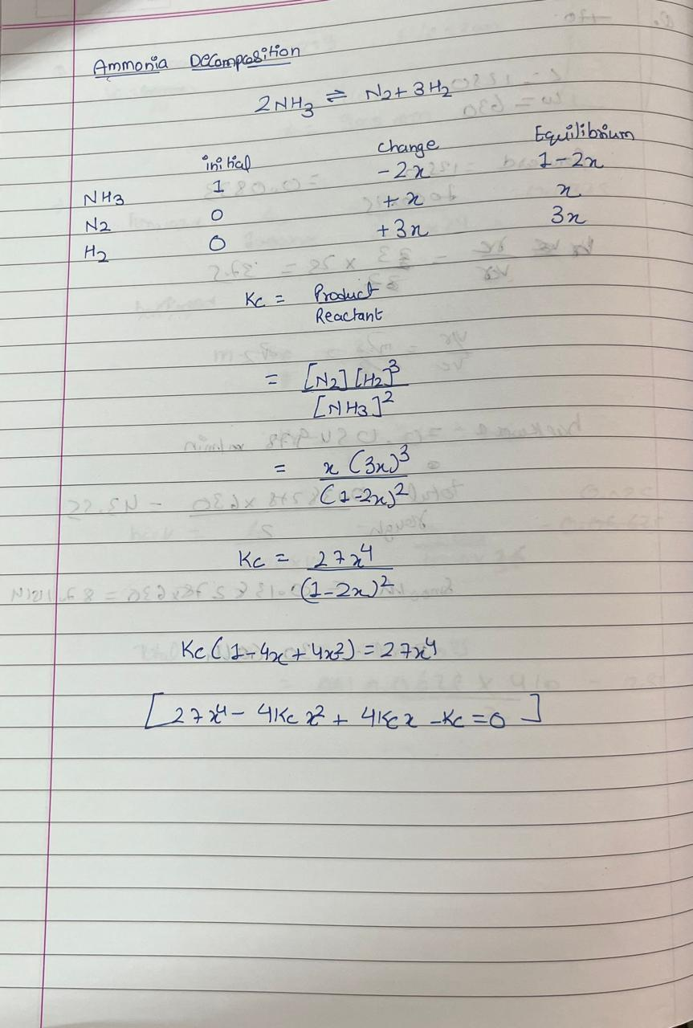
Formation Of Equation: -

